**ECEN 714 Lab 1**

1. Full adder simout, symbol, and schematic

| TOOL: ncxlmode 15.20-s086: Started on Sep 08, 2022 at 16:08:52 CDTncxlmode +delay_mode_path +typdelays -l simout.tmp /home/grads/a/acoskuner500/ecen714/fulladder_run1/testfixture.template -f /home/grads/a/acoskuner500/ecen714/fulladder_run1/verilog.inpfiles /opt/coe/ncsu/ncsu-cdk-1.6.0.beta/lib/NCSU_Digital_Parts/nand2/functional/verilog.v /opt/coe/ncsu/ncsu-cdk-1.6.0.beta/lib/NCSU_Digital_Parts/xor2/functional/verilog.v ihnl/cds0/netlist +nostdout +nocopyright +ncvlogargs+" -neverwarn -nostdout -nocopyright " +ncelabargs+" -neg_tchk -nonotifier -sdf_NOCheck_celltype -access +r -pulse_e 100 -pulse_r 100 -neverwarn -timescale 1ns/1ns -nostdout -nocopyright" +ncsimargs+" -neverwarn -nocopyright -gui -input /home/grads/a/acoskuner500/ecen714/fulladder_run1/.simTmpNCCmd " +mpssession+virtuoso9914 +mpshost+zach-127-24.engr.tamu.edu-------------------------------------Relinquished control to SimVision...ncsim>ncsim> source /opt/coe/cadence/INCISIVE152/tools/inca/files/ncsimrcncsim> database -open shmWave -shm -default -into shm.dbCreated default SHM database shmWavencsim> probe -create -shm test -all -depth 1Created probe 1ncsim> run 0 A=0, B=0, C=0, SUM=0, CARRY=0 50 A=0, B=0, C=1, SUM=1, CARRY=0 100 A=0, B=1, C=0, SUM=1, CARRY=0 150 A=0, B=1, C=1, SUM=0, CARRY=1 200 A=1, B=0, C=0, SUM=1, CARRY=0 250 A=1, B=0, C=1, SUM=0, CARRY=1 300 A=1, B=1, C=0, SUM=0, CARRY=1 350 A=1, B=1, C=1, SUM=1, CARRY=1ncsim> |
| --- |

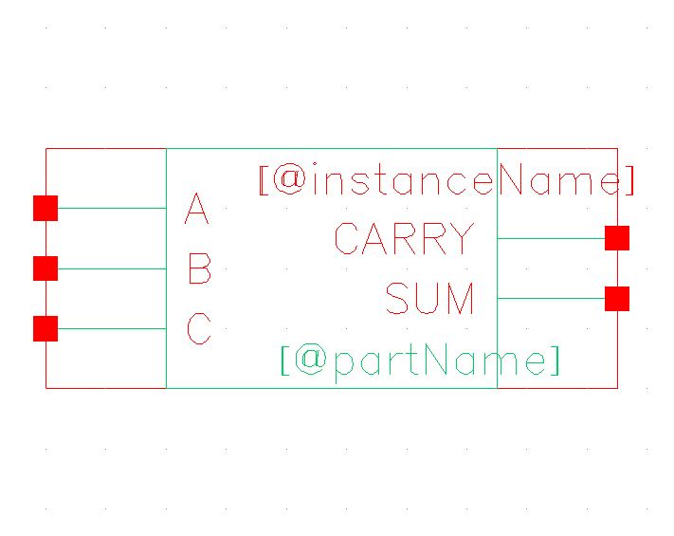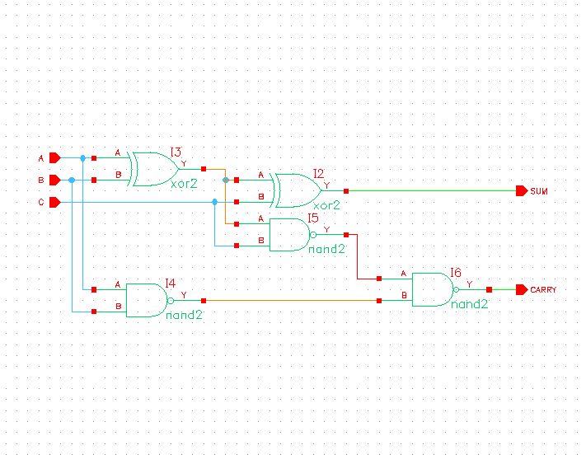

1. 4-bit Adder simout, symbol, and schematic

| TOOL: ncxlmode 15.20-s086: Started on Sep 08, 2022 at 17:12:44 CDTncxlmode +delay_mode_path +typdelays -l simout.tmp /home/grads/a/acoskuner500/ecen714/fouradder_run1/testfixture.template -f /home/grads/a/acoskuner500/ecen714/fouradder_run1/verilog.inpfiles /opt/coe/ncsu/ncsu-cdk-1.6.0.beta/lib/NCSU_Digital_Parts/nand2/functional/verilog.v /opt/coe/ncsu/ncsu-cdk-1.6.0.beta/lib/NCSU_Digital_Parts/xor2/functional/verilog.v ihnl/cds0/netlist ihnl/cds1/netlist +nostdout +nocopyright +ncvlogargs+" -neverwarn -nostdout -nocopyright " +ncelabargs+" -neg_tchk -nonotifier -sdf_NOCheck_celltype -access +r -pulse_e 100 -pulse_r 100 -neverwarn -timescale 1ns/1ns -nostdout -nocopyright" +ncsimargs+" -neverwarn -nocopyright -gui -input /home/grads/a/acoskuner500/ecen714/fouradder_run1/.simTmpNCCmd " +mpssession+virtuoso9914 +mpshost+zach-127-24.engr.tamu.edu-------------------------------------Relinquished control to SimVision...ncsim>ncsim> source /opt/coe/cadence/INCISIVE152/tools/inca/files/ncsimrcncsim> database -open shmWave -shm -default -into shm.dbCreated default SHM database shmWavencsim> probe -create -shm test -all -depth 1Created probe 1ncsim> run 0 A=0000, B=0000, CIN=0, SUM=0000, COUT=0 50 A=1111, B=1111, CIN=0, SUM=1110, COUT=1 100 A=1010, B=1010, CIN=1, SUM=0101, COUT=1 150 A=0101, B=0101, CIN=1, SUM=1011, COUT=0ncsim> |
| --- |

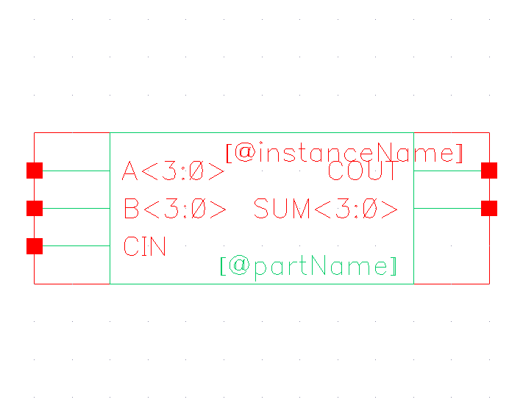

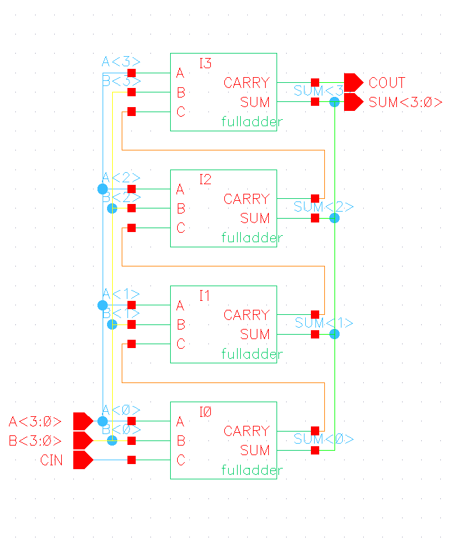

1. 8-bit adder simout, symbol, and schematic

| TOOL: ncxlmode 15.20-s086: Started on Sep 08, 2022 at 19:45:29 CDTncxlmode +delay_mode_path +typdelays -l simout.tmp /home/grads/a/acoskuner500/ecen714/eightadder_run1/testfixture.template -f /home/grads/a/acoskuner500/ecen714/eightadder_run1/verilog.inpfiles /opt/coe/ncsu/ncsu-cdk-1.6.0.beta/lib/NCSU_Digital_Parts/inv/functional/verilog.v /opt/coe/ncsu/ncsu-cdk-1.6.0.beta/lib/NCSU_Digital_Parts/nand2/functional/verilog.v /opt/coe/ncsu/ncsu-cdk-1.6.0.beta/lib/NCSU_Digital_Parts/xor2/functional/verilog.v /opt/coe/ncsu/ncsu-cdk-1.6.0.beta/lib/NCSU_Digital_Parts/Dlatch/behavioral/verilog.v ihnl/cds0/netlist ihnl/cds1/netlist ihnl/cds2/netlist ihnl/cds3/netlist ihnl/cds4/netlist +nostdout +nocopyright +ncvlogargs+" -neverwarn -nostdout -nocopyright " +ncelabargs+" -neg_tchk -nonotifier -sdf_NOCheck_celltype -access +r -pulse_e 100 -pulse_r 100 -neverwarn -timescale 1ns/1ns -nostdout -nocopyright" +ncsimargs+" -neverwarn -nocopyright -gui -input /home/grads/a/acoskuner500/ecen714/eightadder_run1/.simTmpNCCmd " +mpssession+virtuoso9914 +mpshost+zach-127-24.engr.tamu.edu-------------------------------------Relinquished control to SimVision...ncsim>ncsim> source /opt/coe/cadence/INCISIVE152/tools/inca/files/ncsimrcncsim> database -open shmWave -shm -default -into shm.dbCreated default SHM database shmWavencsim> probe -create -shm test -all -depth 1Created probe 1ncsim> run 500ns 0 X=00000000, Y=00000000, CIN=0, SUM=xxxxxxxx, COUT=x 5 X=00000000, Y=00000000, CIN=0, SUM=00000000, COUT=0 50 X=01111110, Y=11100111, CIN=0, SUM=00000000, COUT=0 55 X=01111110, Y=11100111, CIN=0, SUM=01100101, COUT=1 100 X=11111111, Y=00000000, CIN=1, SUM=01100101, COUT=1 105 X=11111111, Y=00000000, CIN=1, SUM=00000000, COUT=1 150 X=10101010, Y=01010101, CIN=0, SUM=00000000, COUT=1 155 X=10101010, Y=01010101, CIN=0, SUM=11111111, COUT=0 200 X=10101010, Y=01010101, CIN=1, SUM=11111111, COUT=0 205 X=10101010, Y=01010101, CIN=1, SUM=00000000, COUT=1 250 X=11001100, Y=00110011, CIN=0, SUM=00000000, COUT=1 255 X=11001100, Y=00110011, CIN=0, SUM=11111111, COUT=0 300 X=11001100, Y=00110011, CIN=1, SUM=11111111, COUT=0 305 X=11001100, Y=00110011, CIN=1, SUM=00000000, COUT=1Ran until 500 NS + 0ncsim> |
| --- |

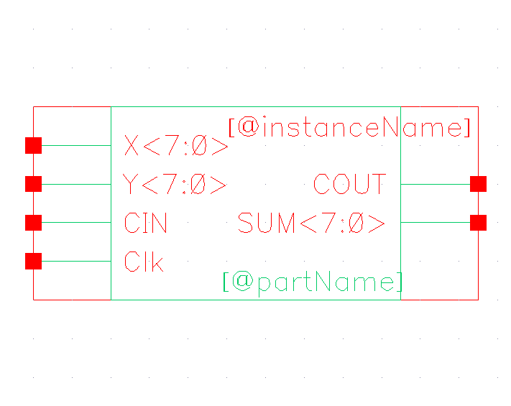

(Rotated for better viewing)

